[THESIS TITLE]

A Thesis submitted by

[Student Name]
([Qualifications])

For the award of

[Insert the name of the program]

[Insert Year (in numbers)]

ABSTRACT
An abstract is a concise summary of the major elements of the academic work, of not more than one A4 page, taking the form of a single paragraph, left justified without sub-headings.

The Abstract should include:
- A brief statement of the research problem
- A brief description of methods
- A brief summary of findings and implications

CERTIFICATION OF THESIS
I [insert Student name] declare that the Thesis entitled [Title of Thesis] is not more than 100,000 words in length including quotes and exclusive of tables, figures, appendices, bibliography, references, and footnotes. The thesis contains no material that has been submitted previously, in whole or in part, for the award of any other academic degree or diploma. Except where otherwise indicated, this thesis is my own work.

Date: [Submission date]

Endorsed by:

[insert name of Principal Supervisor]
Principal Supervisor

[Insert name of Associate Supervisor]
Associate Supervisor

[insert name of Associate Supervisor]
Associate Supervisor
Student and supervisors’ signatures of endorsement are held at the University.

ACKNOWLEDGEMENTS
[You should acknowledge assistance received whilst undertaking the project and preparing the Thesis. You should carefully consider all forms of assistance received - academic, technical, financial, secretarial, administrative, and personal (e.g., family) as appropriate.

If you have received support through the Australian Government Research Training Program, you must acknowledge this support in the Thesis. The correct statement is added below in black ink. The acknowledgements section should not normally exceed one A4 page.]

This research has been supported by the Australian Government Research Training Program Scholarship.

DEDICATION [Optional]

TABLE OF CONTENTS
ABSTRACT i
CERTIFICATION OF THESIS ii
ACKNOWLEDGEMENTS iii
DEDICATION [Optional] iv
LIST OF TABLES vi
LIST OF FIGURES vii
ABBREVIATIONS [Optional] viii
CHAPTER 1: INTRODUCTION 1
1.1. Template text 1
1.2. Example heading two 1
1.2.1. Example subheading one 1
CHAPTER 2: LITERATURE REVIEW 2
2.1. [Heading one] 2
2.1.1. [Subheading one] 2
CHAPTER 3: [INSERT NAME OF CHAPTER] 3
3.1. [Heading one] 3
CHAPTER [final number]: DISCUSSION AND CONCLUSIONS 4
4.1. [Heading one] 4
REFERENCES 5
APPENDIX [A, B, etc.] 6
APPENDIX B 7

LIST OF TABLES
Table 1 [Table title] [insert page number]
Table 2 [Table title] [insert page number]

[List all tables included in the Thesis – Select Table List font style]

Eg. Table [insert number and title] [Press tab] [insert page number]

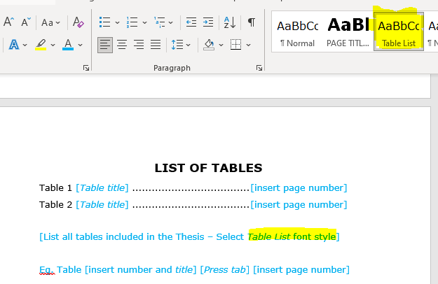
Figure 1 how to select 'Table list' (remove image)

LIST OF FIGURES
Figure 1 [figure title] [insert page number]
Figure 2 [figure title] [insert page number]

[List all figures included in the Thesis – Select Table List font style]

Eg. Figure [insert number and figure title] [Press tab] [insert page number]

ABBREVIATIONS [Optional]
[List all abbreviations used in the Thesis - Select Table List font style]

CHAPTER 1: INTRODUCTION

Template text
Lorem ipsum dolor sit amet, consectetur adipiscing elit. Vivamus fermentum laoreet aliquet. Mauris imperdiet dictum leo, in accumsan lorem maximus vel. Morbi ac malesuada quam, eu lacinia arcu. Ut dignissim, ex quis hendrerit tristique, quam purus volutpat odio, sollicitudin consectetur ligula justo eu turpis. Quisque mi massa, commodo non bibendum ut, pretium sit amet odio.
Etiam accumsan justo libero, sit amet dignissim nisi sollicitudin ut. Praesent a arcu venenatis, bibendum felis eu, consequat turpis. Phasellus eu mauris sit amet nisi posuere tincidunt. Duis imperdiet odio vitae velit gravida finibus. Sed non diam blandit, varius ex vitae, sollicitudin metus. Fusce rutrum diam eu consectetur aliquet.

Example heading two
Morbi ac malesuada quam, eu lacinia arcu. Ut dignissim, ex quis hendrerit tristique, quam purus volutpat odio, sollicitudin consectetur ligula justo eu turpis. Quisque mi massa, commodo non bibendum ut, pretium sit amet odio.
Mauris nec tortor eget odio faucibus venenatis sed id eros. Cras et leo lacinia risus tristique molestie vitae a arcu. Etiam magna sapien, laoreet at nulla sit amet, rutrum vestibulum nisi. Cras tincidunt in risus a congue. Phasellus volutpat lectus id metus vehicula, ac interdum justo porttitor.

Example subheading one
Duis imperdiet odio vitae velit gravida finibus. Sed non diam blandit, varius ex vitae, sollicitudin metus. Fusce rutrum diam eu consectetur aliquet.

CHAPTER 2: LITERATURE REVIEW

[Heading one]

[Subheading one]

CHAPTER 3: [INSERT NAME OF CHAPTER]

[Heading one]

[Continue with the remaining chapters]

CHAPTER [final number]: DISCUSSION AND CONCLUSIONS

[Heading one]

[Continue with the remaining chapters]

REFERENCES
[List all references here in the style relevant to the area of study]

APPENDIX [A, B, etc.]
[Add all appendices, each one starting on a new page]

GENERAL GUIDLINES
This Template provides the basic formatting requirements for Standard Thesis being submitted for examination.

Instructions for Use:
- Delete the blue instructional text as required
- Delete all the square brackets
- Ensure all remaining text has been changed to black ink

Format of a Standard Thesis:
- 12-point font size for the main text
- At least one and a half line spacing
- Consistent font throughout (Verdana is preferred)
- Follow the formatting conventions of the style guide relevant to the area of study (e.g., APA, Harvard, Vancouver)

APPENDIX B
How to update the initial header item numbers for each chapter.

- Highlight your text and select the Heading 2 font style:

- Highlight the numbers and right click on number. Now select Set Numbering Value…
- Select the highlight items and enter the corresponding numbers to the heading (Chapter, Heading)
