

[THESIS TITLE (normally 12 words or less)]

A Thesis submitted by

[Student Name]
([Qualifications])

For the award of

[Insert the name of the program]

[Insert Year (in numbers)]

ABSTRACT
An abstract is a concise summary of the major elements of the academic work, of not more than one A4 page, taking the form of a single paragraph, left justified without sub-headings.

The Abstract should include:
- A brief statement of the research problem
- A brief description of methods
- A brief summary of findings and implications

CERTIFICATION OF THESIS
I [insert Student name] declare that the PhD Thesis entitled [Title of Thesis] is not more than 100,000 words in length including quotes and exclusive of tables, figures, appendices, bibliography, references, and footnotes.
This Thesis is the work of [insert Student name here] except where otherwise acknowledged, with the majority of the contribution to the papers presented as a Thesis by Publication undertaken by the student. The work is original and has not previously been submitted for any other award, except where acknowledged.

Date: [Submission date]

Endorsed by:

[insert name of Principal Supervisor]
Principal Supervisor

[Insert name of Associate Supervisor]
Associate Supervisor

[insert name of Associate Supervisor]
Associate Supervisor
Student and supervisors’ signatures of endorsement are held at the University.

STATEMENT OF CONTRIBUTION
Where published papers have joint authors, a statement must be included within the Preliminary pages of the Thesis declaring that the student made the majority contribution to the conduct of the research and authorship of the papers. Normally, a student would be expected to make more than 50% contribution to each paper. An acknowledgment of the collective contribution of other authors must also be included in this section.

Paper 1:
[Student, A., Author, A., & Author, B. (year). Title of paper, Title of Journal, volume, page range. https://doi.org/XXXX. ]

[Student contributed n% to this paper. Collectively [names of co-authors] contributed the remainder.]

Paper 2:
[Student, A., Author, A., & Author, B. (year). Title of paper.
Submitted to journal]

[Student contributed n% to this paper. Collectively [names of co-authors] contributed the remainder.]

Paper [X]:

ACKNOWLEDGEMENTS
[You should acknowledge assistance received whilst undertaking the project and preparing the Thesis. You should carefully consider all forms of assistance received - academic, technical, financial, secretarial, administrative, and personal (e.g., family) as appropriate.

If you have received support through the Australian Government Research Training Program, you must acknowledge this support in the Thesis. The correct statement is added below in black ink. The acknowledgements section should not normally exceed one A4 page.]

This research has been supported by the Australian Government Research Training Program Scholarship.

ARTIFICIAL INTELLIGENCE DECLARATION
Artificial Intelligence (AI) has/has not been used in the generation of this/these research output(s).

<if “has”, complete the below for each use of AI.>

AI Model Used (Incl. version:
Paid or free version used:
Date of Use:
Purpose of Use:
Prompts used and raw responses generated are available in Appendix #

I, <Student Name>, herby declare that my use of AI in this thesis was undertaken in a manner consistent with the University of Southern Queensland’s Research Code of Conduct Policy and subordinate Procedures and Schedules.

DEDICATION [Optional]

TABLE OF CONTENTS
ABSTRACT i
CERTIFICATION OF THESIS ii
STATEMENT OF CONTRIBUTION iii
ACKNOWLEDGEMENTS iv
ARTIFICIAL INTELLIGENCE DECLARATION v
DEDICATION [Optional] vi
LIST OF TABLES viii
LIST OF FIGURES ix
ABBREVIATIONS [Optional] x
CHAPTER 1: INTRODUCTION 1
1.1. Template text 1
1.2. Example heading two 1
1.2.1. Example subheading one 1
CHAPTER 2: LITERATURE REVIEW 2
2.1. [Heading one] 2
2.1.1. [Subheading one] 2
CHAPTER 3: PAPER 1 – [INSERT TITLE] 3
3.1. Introduction 3
3.2. Links and implications 3
CHAPTER [Final number]: DISCUSSION AND CONCLUSION 4
REFERENCES 5
APPENDIX [A, B, etc.] 6
APPENDIX B 7
APPENDIX C 9

LIST OF TABLES
Table 1 [Table title] [insert page number]
Table 2 [Table title] [insert page number]
[List all tables included in the Thesis – Select Table List font style]

Note: Tables that appear in the thesis chapters of published/submitted papers are not included.

Eg. Table [insert number and title] [Press tab] [insert page number]

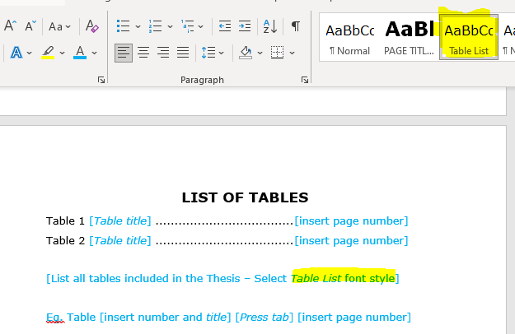
Figure 1 how to select 'Table list' (remove image)

LIST OF FIGURES
Figure 1 [figure title] [insert page number]
Figure 2 [figure title] [insert page number]
[List all figures included in the Thesis – Select Table List font style]

Note: Figures that appear in the thesis chapters of published/submitted papers are not included.

Eg. Figure [insert number and figure title] [Press tab] [insert page number]

ABBREVIATIONS [Optional]
[List all abbreviations used in the Thesis - Select Table List font style]

CHAPTER 1: INTRODUCTION

Template text
Lorem ipsum dolor sit amet, consectetur adipiscing elit. Vivamus fermentum laoreet aliquet. Mauris imperdiet dictum leo, in accumsan lorem maximus vel. Morbi ac malesuada quam, eu lacinia arcu. Ut dignissim, ex quis hendrerit tristique, quam purus volutpat odio, sollicitudin consectetur ligula justo eu turpis. Quisque mi massa, commodo non bibendum ut, pretium sit amet odio.
Etiam accumsan justo libero, sit amet dignissim nisi sollicitudin ut. Praesent a arcu venenatis, bibendum felis eu, consequat turpis. Phasellus eu mauris sit amet nisi posuere tincidunt. Duis imperdiet odio vitae velit gravida finibus. Sed non diam blandit, varius ex vitae, sollicitudin metus. Fusce rutrum diam eu consectetur aliquet.

Example heading two
Morbi ac malesuada quam, eu lacinia arcu. Ut dignissim, ex quis hendrerit tristique, quam purus volutpat odio, sollicitudin consectetur ligula justo eu turpis. Quisque mi massa, commodo non bibendum ut, pretium sit amet odio.
Mauris nec tortor eget odio faucibus venenatis sed id eros. Cras et leo lacinia risus tristique molestie vitae a arcu. Etiam magna sapien, laoreet at nulla sit amet, rutrum vestibulum nisi. Cras tincidunt in risus a congue. Phasellus volutpat lectus id metus vehicula, ac interdum justo porttitor.

Example subheading one
Duis imperdiet odio vitae velit gravida finibus. Sed non diam blandit, varius ex vitae, sollicitudin metus. Fusce rutrum diam eu consectetur aliquet.

CHAPTER 2: LITERATURE REVIEW

[Heading one]

[Subheading one]

CHAPTER 3: PAPER 1 – [INSERT TITLE]

Introduction

[New page* Insert the published paper exactly as published – see Appendix C for instructions]

Links and implications
[Paragraph for the links and implications for next study]

(Repeat with the remaining chapters)

CHAPTER [Final number]: DISCUSSION AND CONCLUSION

REFERENCES
[List all references here in the style relevant to the area of study]

When submitting a Thesis by Publication is it important that the articles/publications are embedded in the thesis exactly as they are published or submitted for publication. Therefore, the references will remain with the article and are not required to be added to this reference list.

This reference list will detail the studies cited in the introduction, literature review, and discussion chapters only.

APPENDIX [A, B, etc.]
[Add all appendices, each one starting on a new page]

GENERAL GUIDLINES
This Template provides the basic formatting requirements for Thesis by Publication being submitted for examination.

Instructions for Use:
- Delete the blue instructional text as required
- Delete all the square brackets
- Ensure all remaining text has been changed to black ink

Format of a Standard Thesis:
- 12-point font size for the main text
- At least one and a half line spacing
- Consistent font throughout (Arial is preferred)
- Follow the formatting conventions of the style guide relevant to the area of study (e.g., APA, Harvard, Vancouver)

APPENDIX B
How to update the initial header item numbers for each chapter.

- Highlight your text and select the Heading 2 font style:


- Highlight the numbers and right click on number. Now select Set Numbering Value…

- Select the highlight items and enter the corresponding numbers to the heading (Chapter, Heading)
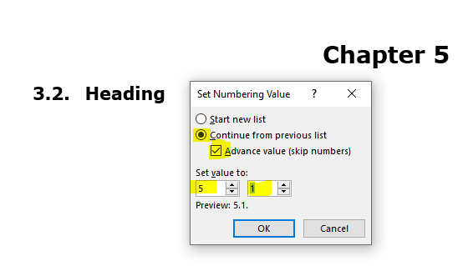

APPENDIX C
Example method for inserting a PDF publication into a Chapter

- Open a PDF version of the publication via Adobe Acrobat
- Export the PDF to PNG file for each page by using the File > Export to > Image > PNG tabs
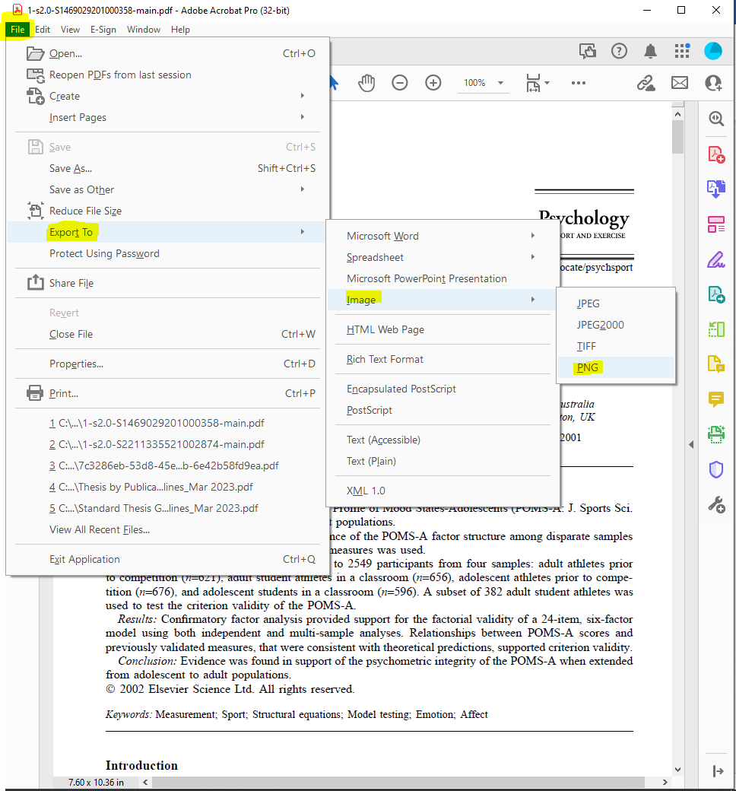
- Select the save location and hit save. A PNG file for each page will be generated.
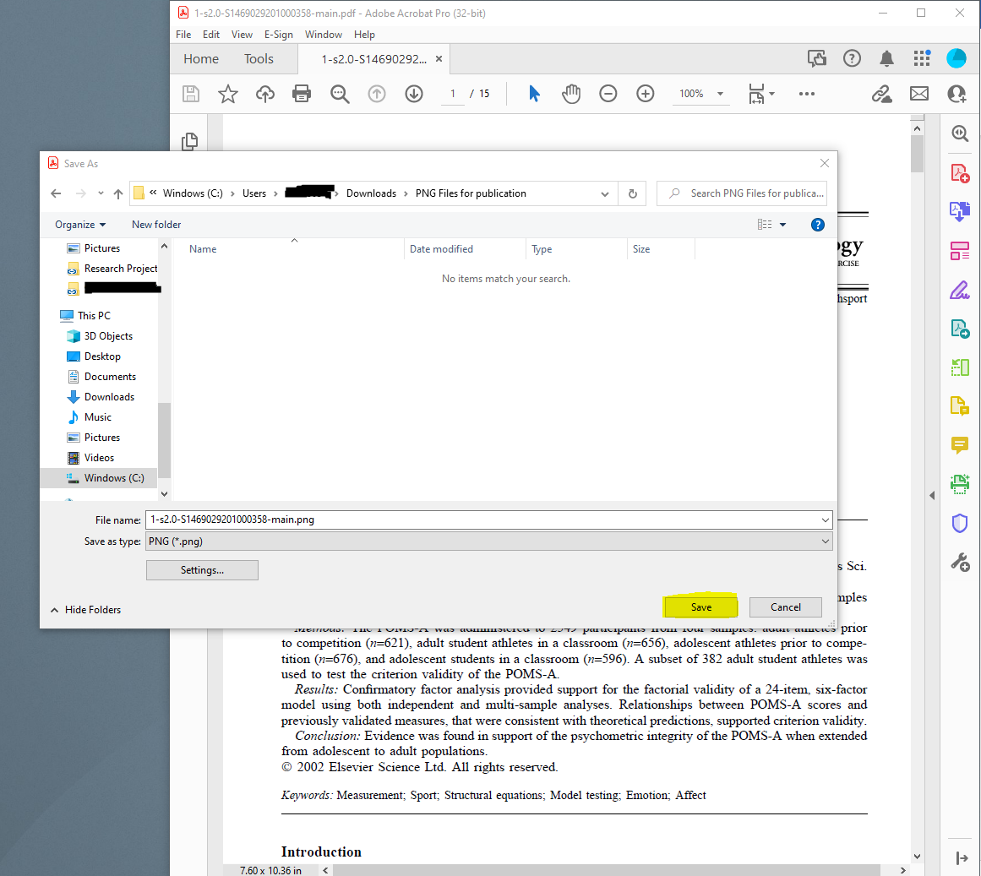
- Navigate to the folder where the files were saved. Select all the files and perform a “drag and drop” into your Thesis Word document in the appropriate section.
- Check the order of inserted images, resize to if required, to ensure the page margins are maintained.

