How to register for a graduation ceremony (Deferred)
Congratulations! You are already a USQ graduate, and now it’s time to register for your Deferred Graduation Ceremony via the online Graduate Response.

Log into your Student Centre
1. Open the USQ homepage by clicking on: http://www.usq.edu.au
2. Click the UConnect button located at the top of the page.

3. Enter your Student ID and Password and click the Logon button.
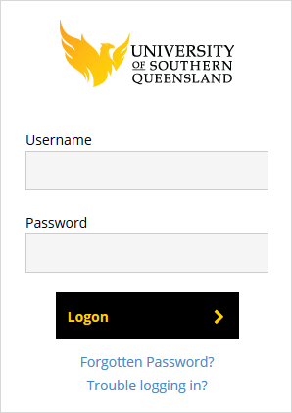
4. Click on the Student Centre button.
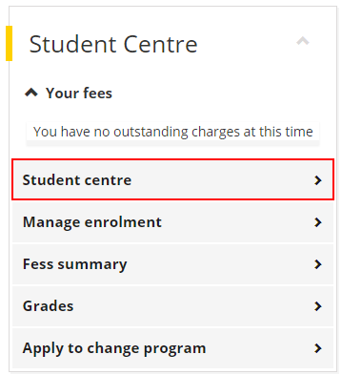
5. Welcome to the Student Centre home page.
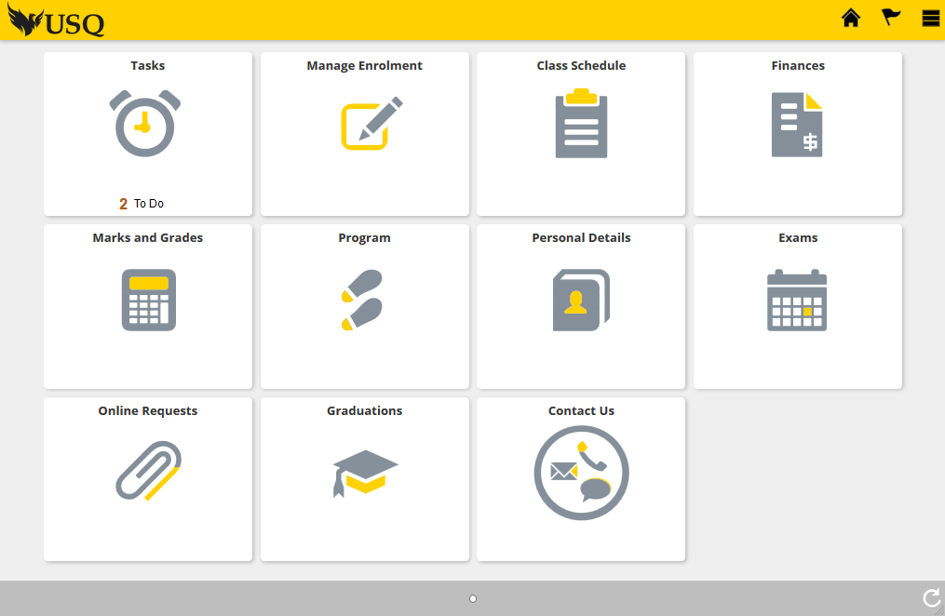

Register for a Celebration (Deferred Graduation Ceremony)
1. On the Student Centre home page, click on the Graduations tile.

2. Your Graduation Status screen shows the program that you’ve already graduated from i.e. your (Primary Graduation Ceremony). You should have completed the online Graduate Response previously to receive your print testamur. If you did not complete this at the time, the Graduations Office completed this for you.
*DO NOT select the Primary Graduation Ceremony option.
You must select the (Deferred Graduation Ceremony) option.

3. Once the ‘Deferred Graduation Ceremony’ option is selected, click on the Program you wish to attend a Celebration to receive i.e. typically, your highest award. It will be at ‘Not Started’ status.
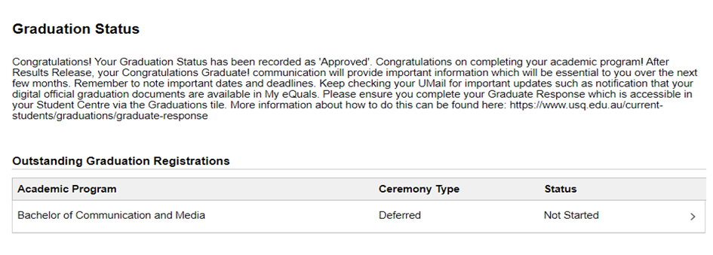
4. Select the ‘I would like to attend a Graduation Ceremony’ option.

5. You will need to confirm your graduation details by completing the following pages.
6. Click the Start button to begin.


7. If you agree to the terms listed in the Collection Notice, click the Accept button.
8. The Graduation Ceremonies will be displayed on Step 2. Click on the Ceremony you would like to attend.
(Note: The screenshot provided below is an example. The list of graduation ceremonies you see will be specific to your ceremony season.)
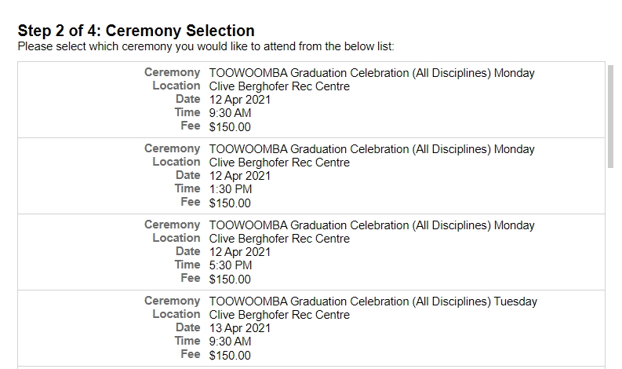
9. Once you have made your selection, click the Confirm button.
10. Step 3, which relates to Guest Tickets and Academic Dress sizing is dependent on the ceremony you have selected to attend.

- If you are attending a Sydney ceremony select the number of guests you will be bringing (AUD30 per guest). You MUST complete this section.

- If you are attending a Toowoomba or Ipswich ceremony, you will be allocated the maximum 5 guests automatically. No need to compete this section.

- If you are attending a Doctoral only ceremony in Toowoomba, you will be allocated the maximum 10 guests automatically. No need to compete this section.

It is NOT necessary to provide your academic dress requirements.
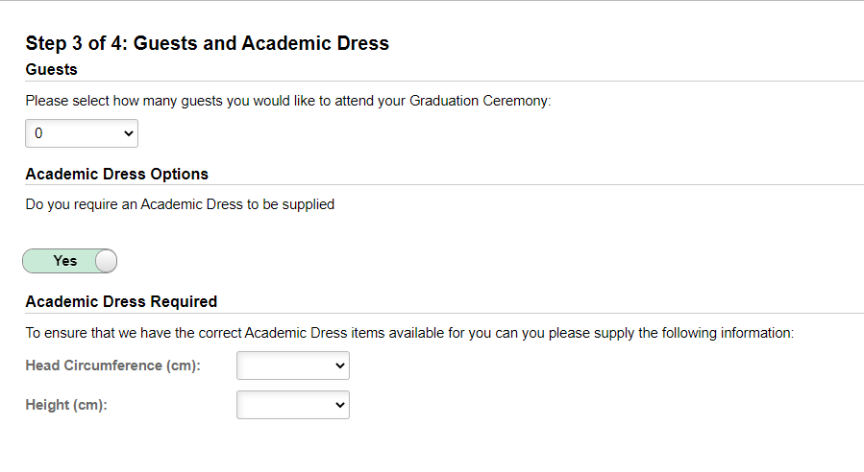

11. Check the Graduation Registration Summary has recorded your correct information.
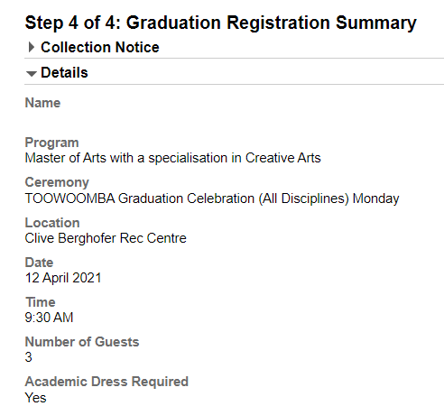

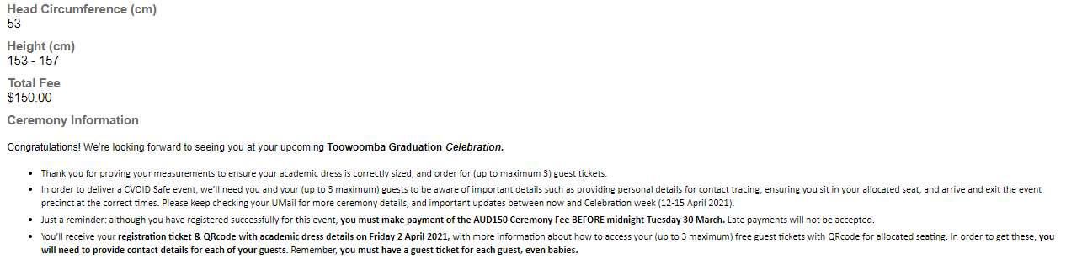

12. When you are ready to finalise your graduation registration, click the Submit button.

13. Click the Make a Payment button to pay your ceremony fee online.
Change Pending (incomplete) Registration
If you have started the Online Graduate Response and would like to make changes, you have the ability to discard your registration while it is at ‘Pending’ status.
If you would like to change your registration, click the Actions List icon at the top of your page and select the Discard option. The Discard option will only become available after the first three steps of the Online Graduate Response have been completed.
Note: The Online Graduate Response is considered ‘Pending’ up until the Submit button is clicked on the final step of registration.


Change Submitted Registration
If you have submitted the Online Graduate Response and need to make change, you must contact the Graduations Office to do so.
Please contact graduations@usq.edu.au or call Freecall 1800 007 252 and ask to be forwarded to the Graduations Office.

