Congratulations! You have completed your academic program and are now a USQ graduand.
How to register for Mail my testamur or a graduation ceremony (Primary)

Now it’s time to register for a graduation ceremony, or ‘Mail my testamur’, via the online Graduate Response (Primary Graduation Ceremony).
Regardless of whether you register for a ceremony or ‘Mail my testamur’, your print testamur will be sent directly to you in a COVID Safe manner. If you have studied with a USQ Education Partner, your print testamur will be sent directly to the Partner.

Log into your Student Centre
1. Open the USQ homepage by clicking on: http://www.usq.edu.au
2. Click the UConnect button located at the top of the page.

3. Enter your Student ID and Password and click the Logon button.
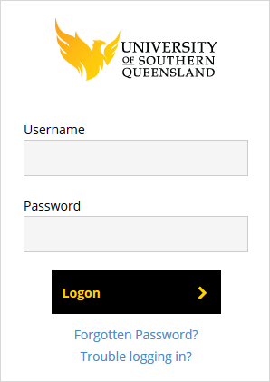

4. Click on the Student Centre button.
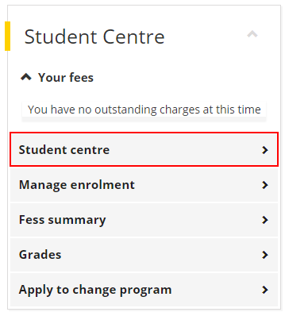
5. Welcome to your Student Centre home page, and the Graduations tile.
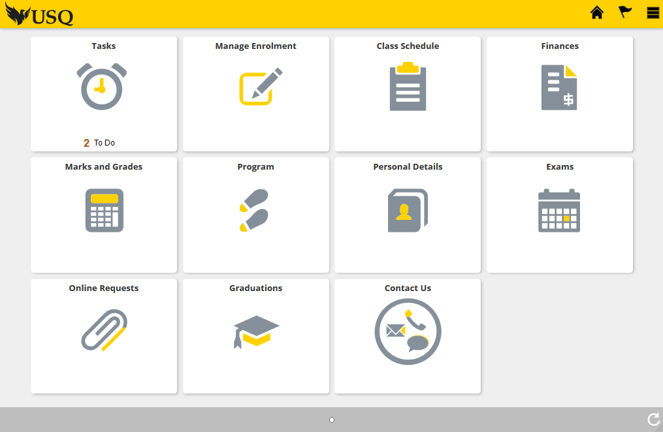

Register for ‘Mail my testamur’ or a graduation ceremony
1. Click on the Graduations tile.


2. Your Graduation Status will show the academic program (award) that you are Approved to graduate from, and an option to select ‘Primary Ceremony Type’.
This will be at ‘Not Started’ status.
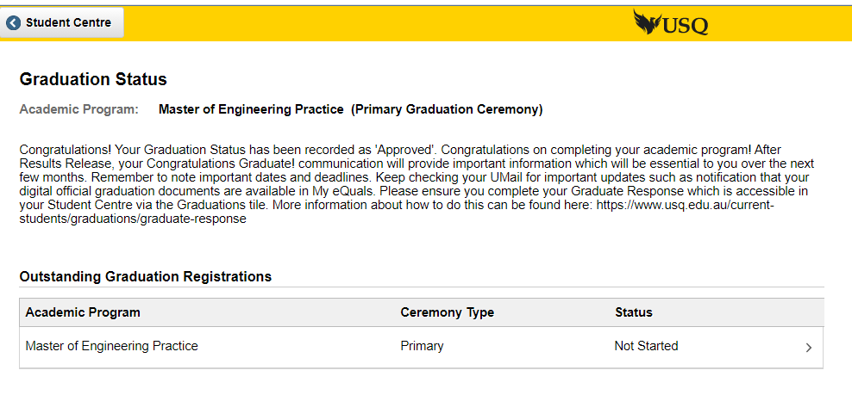
You are now required to select from either Mail my testamur OR a Graduation Ceremony and follow the prompts.
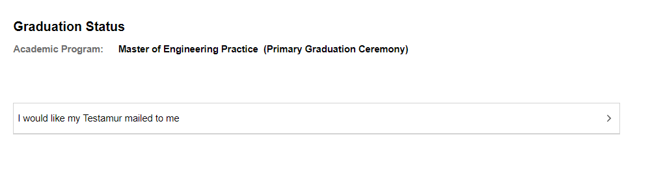


3. If you select ‘I would like my Testamur mailed to me’, you will see a Welcome page outlining how to enter your details. Go to page 5 and continue through the instructions.
Alternately, if you select a Graduation Ceremony location/date/time this detail will appear, and you will see a Welcome page. Continue through the process until you complete and Submit. Please note the following for the current round of graduation ceremonies:
Step 3, which relates to Guest Tickets and Academic Dress sizing is dependent on the ceremony you have selected to attend.

- If you are attending a Sydney ceremony select the number of guests you will be bringing (AUD30 per guest). You MUST complete this section.

- If you are attending a Toowoomba or Ipswich ceremony, you will be allocated the maximum 5 guests automatically. No need to compete this section.

- If you are attending a Doctoral only ceremony in Toowoomba, you will be allocated the maximum 10 guests automatically. No need to compete this section.

It is NOT necessary to provide your academic dress requirements (see below).

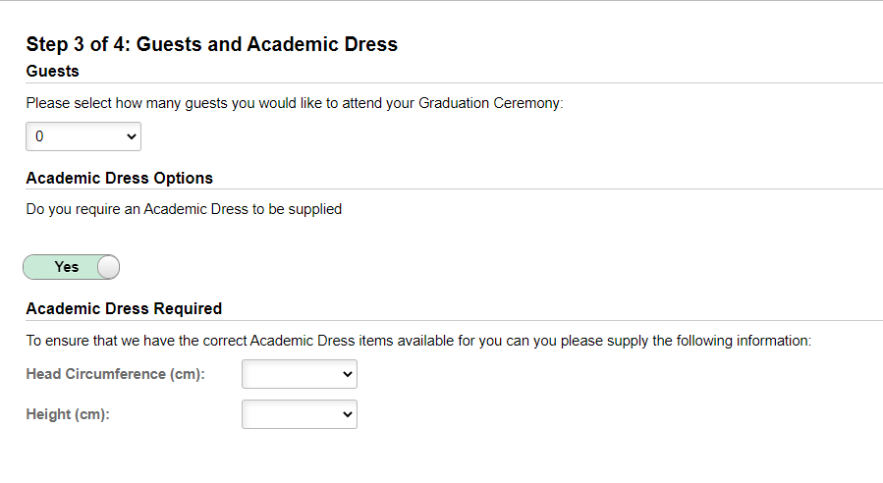
Follow the prompts and be sure to Submit your graduation ceremony registration when complete.

If you selected Mail my testamur, instead of a ceremony:
This message will appear
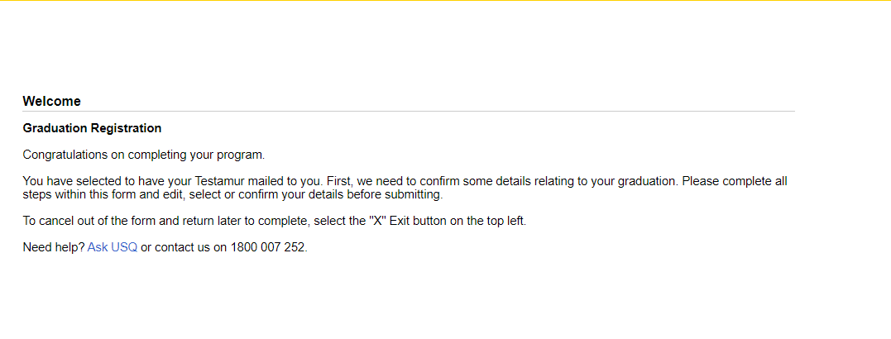
4. Click the Start button to begin.

5. If you agree to the terms listed in the Collection Notice, click the Accept button.
6. If required, select or confirm your Primary Major.
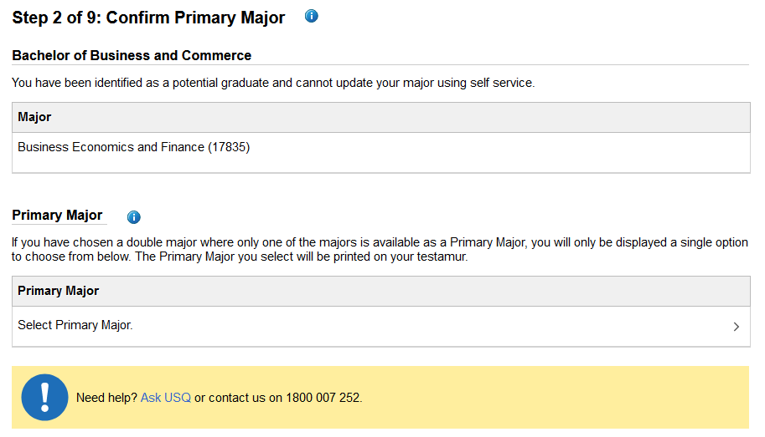
6. Check your Program details listed on Step 2 are correct as this will be printed on your Testamur.

7. Click the Confirm button to continue.

8. Check your Name is correct as this will be printed on your testamur exactly as it is shown on Step 3.
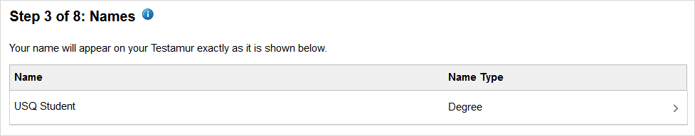
9. If your name is incorrect, click on your name to submit an online ‘Name Change Request’.
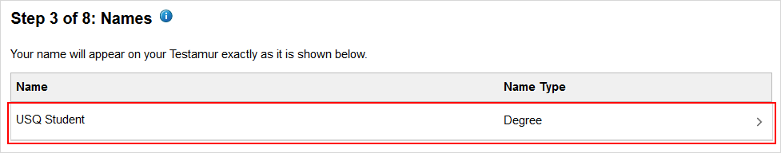
10. If your name is correct, click the Confirm button to continue.
11. Check your Email addresses are correct. Click on an existing email address to edit the information.
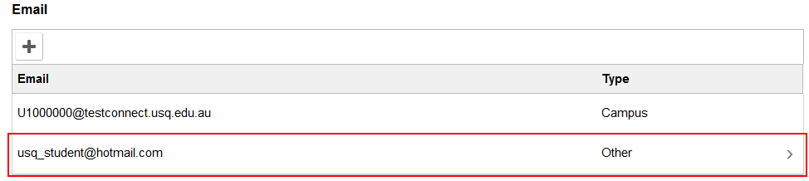
12. Click the Add button to record a new email address.

13. Check your Phone information is correct. Click on an existing Phone number to edit the information.
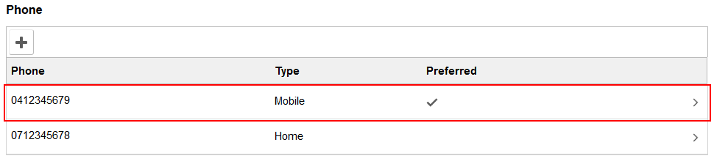
14. Click the Add button to record a new phone number.
15. Once you have updated your information on Step 4, click the Confirm button to continue.
16. Check your Mailing Address is correct. Click on your existing mailing address to edit the information.
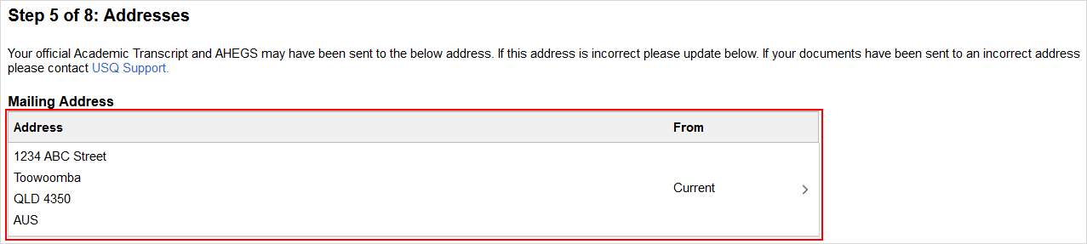
17. Once you have updated your information on Step 5, click the Confirm button to continue.
18. Check the Graduation Registration Summary has recorded your correct information.
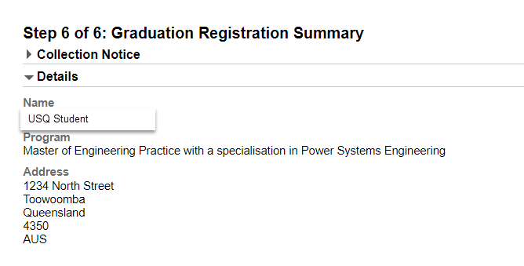
19. When you are ready to finalise your graduation registration, click the Submit button.

Change Pending (incomplete) Registration
If you have started the Online Graduate Response and would like to make changes, you have the ability to discard your registration while it is at ‘Pending’ status.
If you would like to change your registration, click the Actions List icon at the top of your page and select the Discard option. The Discard option will only become available after the first three steps of the Online Graduate Response have been completed.
Note: The Online Graduate Response is considered ‘Pending’ up until the Submit button is clicked on the final step of registration.


Change Submitted Registration
If you have submitted the Online Graduate Response and need to make change, you must contact the Graduations Office to do so.
If you require support, please contact graduations@usq.edu.au or Freecall 1800 007 252 and ask to be forwarded to the Graduations Office.

